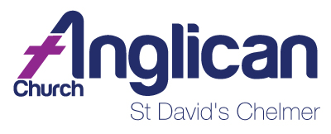

WEEKLY BULLETIN: 3 July 2022
Fourth Sunday after Pentecost

Welcome to everyone worshipping with us this Sunday in the church building or via Livestream, and greetings to anyone reading this on the parish website.
We also welcome family, godparents and friends of Wallace James Fisher (4 years old) and Lucy Amelia Fisher (6 months old) being baptised in our 9.30am service today.
Nic will be away for all of July. We welcome Fr George Markotsis who in Nic’s absence will be the presiding priest and preacher at the parish. George can be contacted on 0421 830 778 and via email on frgeorgewm@outlook.com.

The National Church Life Survey (NCLS) has been handed out to a number of parishioners to complete. The deadline for completing the survey is Sunday 24 July. A box is placed at the entrance for returned surveys or the survey can be dropped at the parish office on a Monday, Wednesday or Friday morning.

There are some spares available for anyone who would like to complete the survey. Contact Kim in the parish office.
~~~~~~~~~~~~~~~~~

Parish News:

PARISH OFFICE: Kim will take leave during the school holidays on Wednesday 6 July.

KEITH THORNE: Keith died peacefully on Monday 27 June at 8am, at Canossa. He did not want a funeral; however, his family may hold a wake for him in due course. The parish office is waiting on feedback from his family and will keep you all updated.

BREAD TAGS FOR WHEELCHAIRS: Please save your PLASTIC bread tags. They are made of a specific type of plastic which is expensive and can be recycled for charity funds for wheelchairs. Judy and Richard Ford have initiated this for a project in South Africa. Please see the noticeboard for more information and direct any questions to Judy or Nic.

Community News:

ST THOMAS’ BOOKSHOP: The bookshop is open weekly on Thursday from 10am to 3pm. The bookshop has a wide variety of pre-loved books at reasonable prices. All are welcome to drop in for a cuppa and a chance to purchase a special book.

NAIDOC WEEK (3-10 July): NAIDOC Week celebrations are held across Australia each July to celebrate the histories, cultures and achievements of Aboriginal and Torres Strait Islander peoples. NAIDOC Week is celebrated not only by Indigenous communities, but also Australians from all walks of life.

The week is a great opportunity to participate in a range of activities and to support your local Aboriginal and Torres Strait Islander community. As a church who is committed to reconciliation, both in general and specifically with First Nations people, NAIDOC Week gives us an opportunity to put our beliefs in action. The NAIDOC Week website has many resources and ideas that are worth exploring. Visit www.naidoc.org.au.
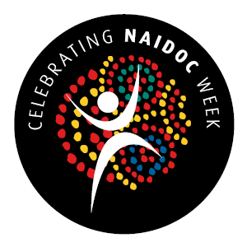

At 9.30am service we read the second reading and Gospel only
 | First Reading | Psalm | Second Reading | Gospel
3 July | 2 Kings  5.1-14 | 30 | Galatians 6.7-18 | Luke 10.1-12,  17-24
10 July | Amos 7.7-17 | 82 | Colossians 1.1-14 | Luke 10.25-37

Parish Contacts:
Wardens: | Parish Priest: | Office:
Laurena Graham  Karen Green | Nic Denny-Dimitriou  Is on leave for all of July. For Pastoral Care please contact  Fr George Markotsis on  0421 830 778. | OPEN: Mon & Fri:  9am – 11 am  0401 118 184  chelmer@anglicanchurchsq.org.au

